https://learn.microsoft.com/en-us/azure/virtual-network/virtual-network-peering-overview

Intersite connectivity in Azure refers to linking different network environments—such as Azure Virtual Networks (VNets) to each other or on-premises data centers to Azure. It uses Microsoft's private global backbone to ensure secure, high-speed, and low-latency communication. [1, 2, 3, 4, 5]
The most common methods to establish this connectivity in Azure include:
1. VNet-to-VNet Connectivity
Connects two different Azure Virtual Networks directly.
- Virtual Network Peering: Seamlessly connects two VNets in the same or different Azure regions. The traffic between the two networks travels on Microsoft’s private backbone, is highly secure, and experiences no latency penalties.
- VNet-to-VNet VPN Gateway: Connects VNets using a traditional IPsec/IKE VPN tunnel, which is ideal if you need to enforce additional encryption at the gateway level or span across multiple subscriptions. [1, 2, 3, 4, 5]
2. On-Premises to Azure (Hybrid) Connectivity
Connects your local offices, branch offices, or data centers to your Azure Virtual Networks.
- VPN Gateway: Establishes a secure, encrypted connection over the public internet between your on-premises VPN device and your Azure VNet. This is available in both Route-Based and Policy-Based configurations.
- ExpressRoute: Bypasses the public internet entirely to create a private, highly reliable, and faster connection from your on-premises infrastructure to Azure via a dedicated connectivity provider.
3. Global Enterprise Connectivity (Hub-and-Spoke)
Ideal for connecting multiple branch offices and cloud environments at a global scale.
- Azure Virtual WAN: A networking service that brings many cloud and on-premises capabilities together, including branch-to-branch, VNet-to-VNet, and remote user (Point-to-Site) connectivity. It manages large-scale routing globally via the Azure backbone. [1, 2, 3]
4. Direct Resource Access
- Azure Bastion: Provides secure and seamless RDP and SSH access directly to your Azure virtual machines through the Azure Portal in your browser, without needing public IP addresses assigned to the VMs.
- Private Link: Connects Azure PaaS services (like Azure SQL or Storage) and private endpoints directly to your VNet, keeping the traffic entirely within the Microsoft network. [1, 2, 3, 4, 5]
To explore and set up these services in your environment, visit the Azure Virtual Network Documentation for step-by-step guidance.

Azure Virtual Network (VNet) peering enables seamless, high-performance connectivity between Azure virtual networks, making them appear as one for traffic purposes. Traffic stays entirely within Microsoft’s private backbone infrastructure, offering a secure, low-latency alternative to VPN gateways, even across different regions (Global Peering) or subscriptions. [1, 2, 3]

Key Aspects of VNet Peering
- Performance & Security: Traffic between peered VNets is routed directly through the Azure backbone, not the public internet.
- Types of Peering:
  - Regional Peering: Connects VNets within the same region.
  - Global Peering: Connects VNets across different Azure regions.
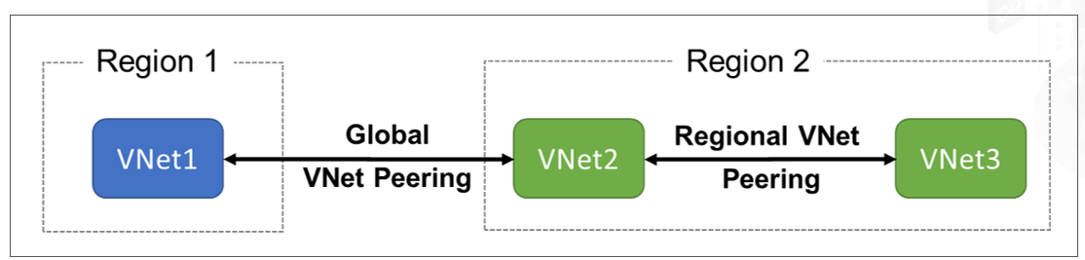
- Connectivity Scope: Resources (VMs, databases) in peered VNets can communicate directly via private IP addresses.
- Non-Transitive: If VNet A is peered with VNet B, and B with VNet C, A is not automatically connected to C.
- Topology Options: Supports Hub-and-Spoke, Mesh, and complex network designs. [1, 2, 3, 4, 5]
How to Configure VNet Peering
- Navigate to your Virtual Network in the Azure Portal.
- Select Peerings under Settings and click + Add.
- Enter a name for the peering link and select the target Virtual Network.
- Configure settings such as allowing forwarded traffic or gateway transit.
- Create the pairing. Note: You must create a reciprocal pairing from the other virtual network back to the first for connectivity to be active. [1, 2, 3, 4, 5]

Important Considerations
- Address Space: Peered virtual networks cannot have overlapping IP address spaces.
- Name Resolution: By default, private DNS resolution across peered VNets does not work unless explicitly configured.
- NSGs: Security rules in Network Security Groups (NSGs) can still block traffic between peered networks.
- Sync Requirements: If you update the address space of a peered VNet, you must use the 'Sync' feature in the portal to update the remote peering.
Lab:
Connect virtual networks with virtual network peering
https://learn.microsoft.com/en-us/azure/virtual-network/tutorial-connect-virtual-networks?tabs=portal

